A Smart Chatbot Architecture based NLP and Machine learning for health care assistance.

1)What is this paper about?

The chatbot technologies has huge applications along different domain sectors such finance, IT, Medical, Logistics, Business etc. Since chatbot could help doctors, nurses, patients, or their families.  
Better organization of patient information, medication  
management, helping in emergencies or with first aid, offering a  
solution for superficial medical issues: these are all possible  
situations for chatbots to step in and reduce the burden on medical  
professional. This Academia mainly concentrates proposing a chatbot bot architecture in the medical field industries. The basis of the paper is based on survey analysis made by observing different chatbot academia papers chosen recent 5 years ago, it observers that in the past, only statistic methods were implemented for developing a chatbot architecture, but now with the help of AI and ML and end to deep learning neural networks and an Encoder Decoder model has been shown the most profound use, this is captured from Neural Machine translation domain. So here they understand various research paper from the past and produce different related works on their subject. Chatbots are conversational agents if treated wrong it can malfunction and treat users abruptly by fooling them or make stupid decisions.

2)What are the authors doing that is new?

The authors building a sophisticated chatbot architecture with help of NLP which can identify text classification for Natural Language understanding here its contains two main components called NLG that is Natural Language Understanding (NLU) , Natural Language Generation, on top of that NLP has structure for making text understating much more simple these labels are

1)Lexical Analysis: Analyses word structure.

2)Syntactic Analyser: Helps in Parsing and Text Processing.

3)Semantic Analysis: Helps in Understanding the meaning of a sentence

4) Pragmatic analysis and discourse integration: Helps in Analysing sentence relay of contextual data

Proposed Architecture:

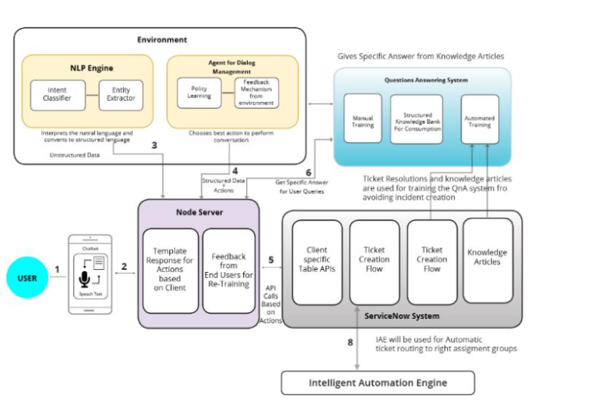

Consists of Environment The place where the fundamental Natural Learning Process (NLP) engine and context clarification occurs,

NLP Engine: Contains Algorithms such as Intent classifier and Entity Extractor also Agent for Dialogue Management has key plugins such as feedback learning and policy learning.

Question And Answer system, Plugins and components, Node server, Front-end system.

3)Did it work? why or why not?

Data produced is Inconclusive.

4)Why is this good or bad?

Many relevant works are proposed similar to this paper so ideally the chatbot are adapting a thinking a learning process here, I think its methods are less advance for building the chatbot.

5)Technical Specifications of the Paper

Chatbots, artificial intelligence, conversational agents, modelling  
of conversations, natural language, neural machine translations.

6)Conclusions.

Help to produce excellent state of the art chatbot architecture for medical field to increase its productivity and support other medical features to perform full and accurate diagnosis of patient’s diseases

Future work yet to be done.